IN26012154

ASP.NET Core Web MVC Integration,Unit Testing & GitHub
Help Desk Ticket Manaqement System

Name: Akhil Astitva
Application No.: IN26012154
03 August 2026

HELP DESK TICKET MANAGEMENT SYSTEM
Complete Project Architecture, Source Code & Application Screenshots Report
MP Online Project Submission - August 01

1. Executive Summary & Project Objective
The Help Desk Ticket Management System (HelpDeskManagement) is an end-to-end web application developed for managing internal employee IT support requests. Built using ASP.NET Core 10.0 Web API, Entity Framework Core, SQL Server, ASP.NET Core MVC, and xUnit with Moq, the system enables employees and IT support staff to create, view, filter, edit, and resolve support tickets.
2. System Architecture & Technical Stack
• Web API Layer (HelpDesk.Api): Implements RESTful HTTP endpoints for Ticket CRUD operations. Implements the Repository Pattern (ITicketRepository, TicketRepository) and EF Core DbContext for SQL Server.
• MVC Layer (HelpDesk.Mvc): Front-end web interface using Razor Views and a dedicated Service Layer (TicketService) consuming Web API via HttpClient. Styling adheres strictly to a minimalist monochrome aesthetic (black/white contrast, square edges, single regular font weight).
• Unit Test Layer (HelpDesk.Tests): Independent test project with 13 xUnit unit tests mocking ITicketRepository via Moq to verify API controller logic.
3. Application Screenshots & Visual Proof
The following figures present actual application screenshots captured from the running local environment:
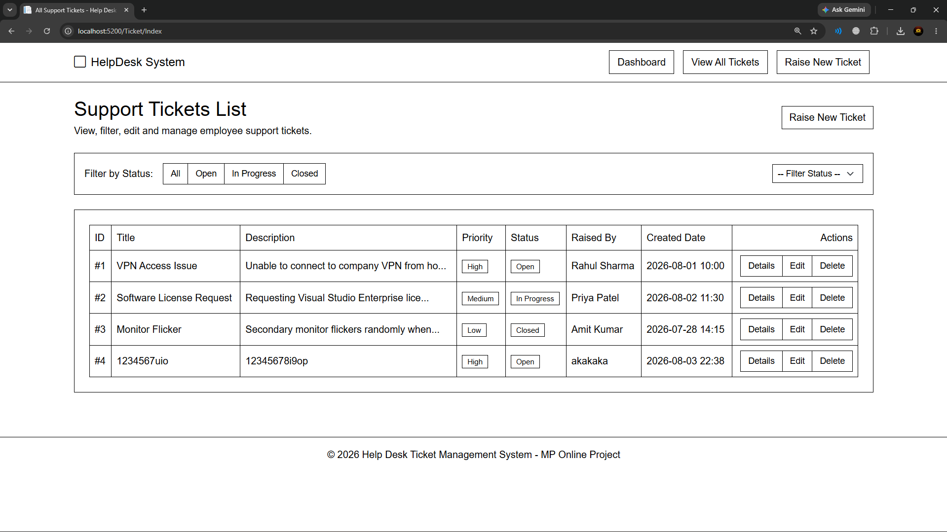
Figure 1: ASP.NET Core Web API Execution Logs & Port Binding Verification
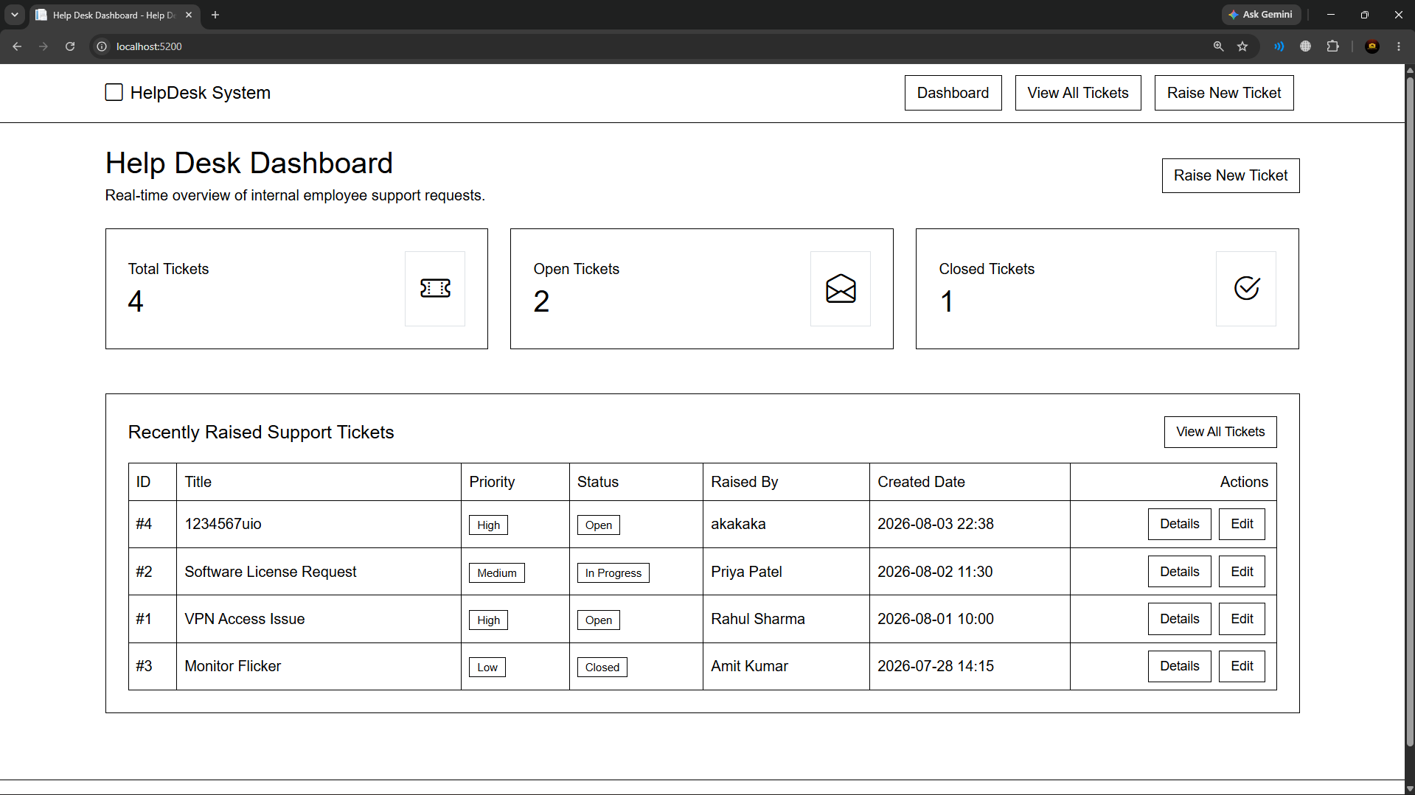
Figure 2: Help Desk System Dashboard Overview (Total, Open, and Closed Ticket Cards)
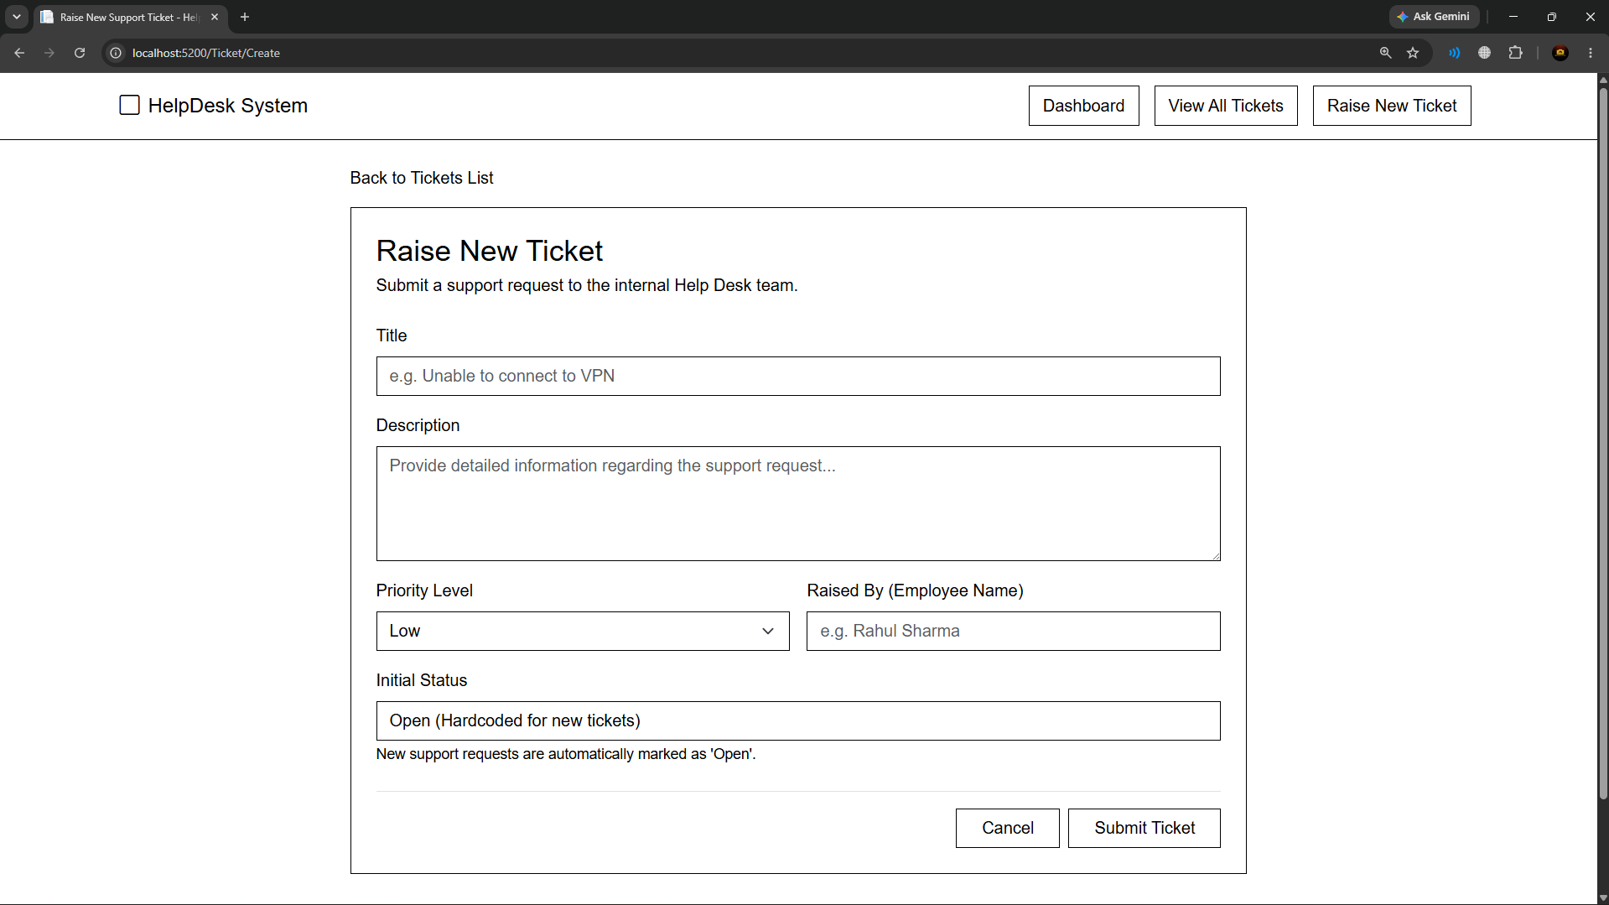
Figure 3: Support Tickets List Table View with Interactive Status Filters
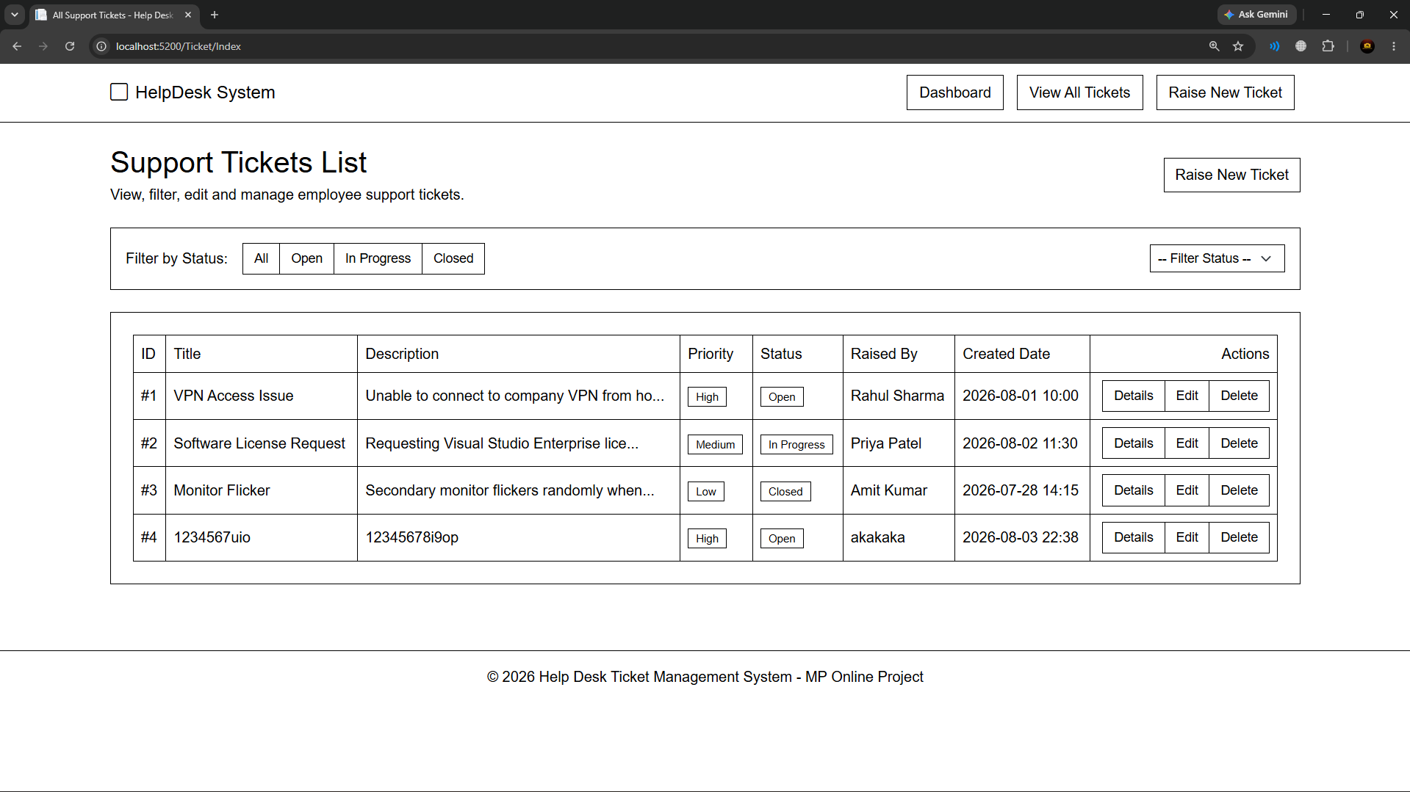
Figure 4: Detailed View of Individual Support Ticket
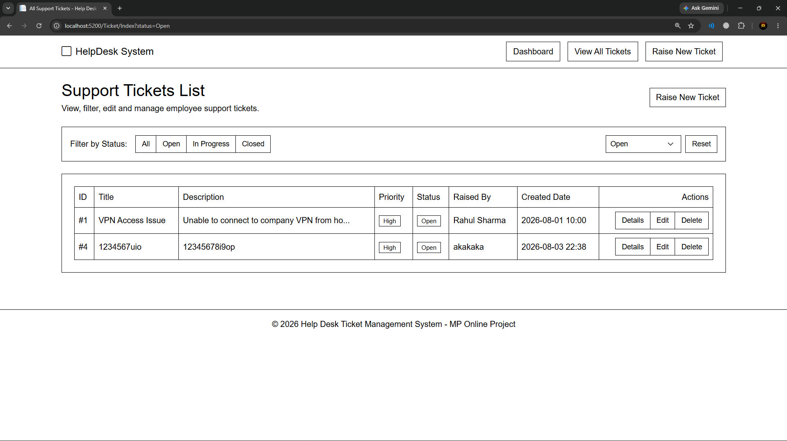
Figure 5: Raise New Support Ticket Form (Status Hardcoded to Open)
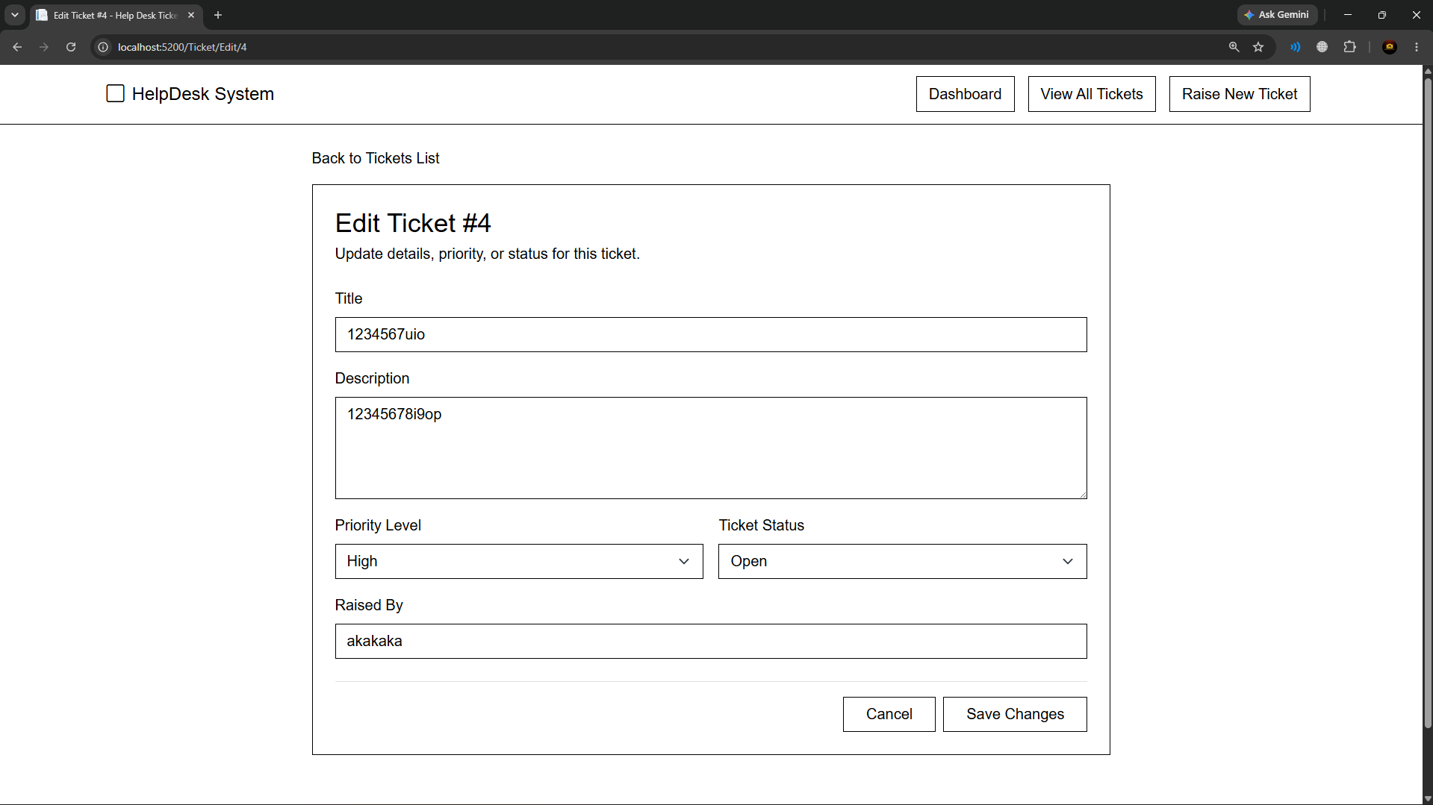
Figure 6: Edit Ticket Form (Updating Priority & Status Drops)
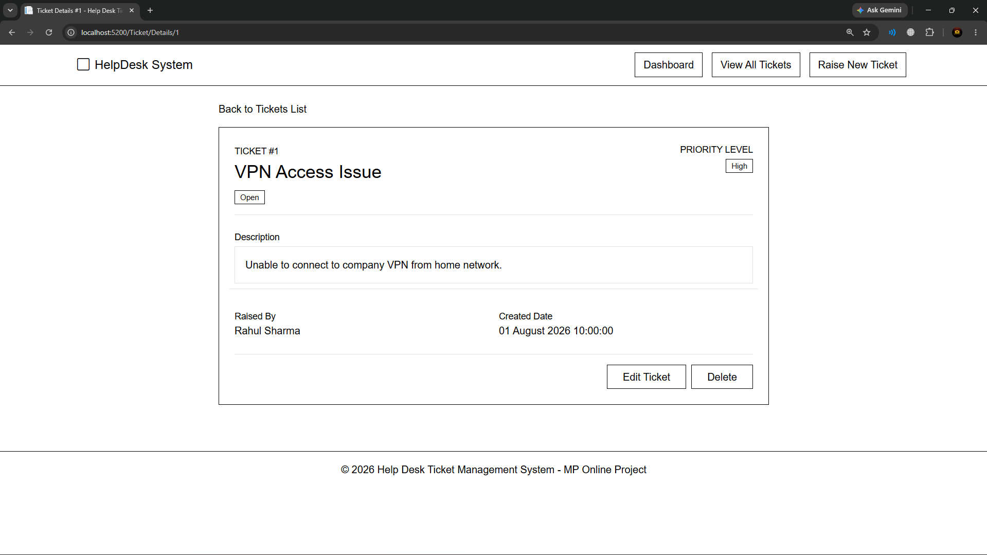
Figure 7: Delete Ticket Confirmation Page
4. REST API Endpoint Specifications
HTTP Method | API Endpoint | Description
GET | /api/Ticket/All | Retrieve list of all support tickets
GET | /api/Ticket/{id} | Retrieve specific ticket details by ID
POST | /api/Ticket | Create a new support ticket
PUT | /api/Ticket/{id} | Update an existing support ticket
DELETE | /api/Ticket/{id} | Delete support ticket by ID
GET | /api/Ticket/Status/{status} | Filter support tickets by status (Open/In Progress/Closed)

5. Unit Testing Execution Results
All 13 unit test cases (6 mandatory + 7 extended/optional) were executed using xUnit and Moq against the Web API TicketController. All 13 tests passed successfully with 0 failures.
6. Complete Source Code Listings
📄 HelpDesk.Api/Models/Ticket.cs
namespace HelpDesk.Api.Models
{
public class Ticket
{
public int Id { get; set; }
public string Title { get; set; } = string.Empty;
public string Description { get; set; } = string.Empty;
public string Priority { get; set; } = "Low"; // Low, Medium, High
public string Status { get; set; } = "Open"; // Open, In Progress, Closed
public string RaisedBy { get; set; } = string.Empty;
public DateTime CreatedDate { get; set; } = DateTime.Now;
}
}

📄 HelpDesk.Api/Data/HelpDeskDbContext.cs
using HelpDesk.Api.Models;
using Microsoft.EntityFrameworkCore;
namespace HelpDesk.Api.Data
{
public class HelpDeskDbContext : DbContext
{
public HelpDeskDbContext(DbContextOptions<HelpDeskDbContext> options) : base(options)
{
}
public DbSet<Ticket> Tickets { get; set; }
protected override void OnModelCreating(ModelBuilder modelBuilder)
{
base.OnModelCreating(modelBuilder);
// Pre-populate initial support tickets for testing and demonstration
modelBuilder.Entity<Ticket>().HasData(
new Ticket
{
Id = 1,
Title = "VPN Access Issue",
Description = "Unable to connect to company VPN from home network after recent update.",
Priority = "High",
Status = "Open",
RaisedBy = "Rahul Sharma",
CreatedDate = new DateTime(2026, 8, 1, 10, 0, 0)
},
new Ticket
{
Id = 2,
Title = "Software License Request",
Description = "Requesting Visual Studio Enterprise license key for the upcoming project.",
Priority = "Medium",
Status = "In Progress",
RaisedBy = "Priya Patel",
CreatedDate = new DateTime(2026, 8, 2, 11, 30, 0)
},
new Ticket
{
Id = 3,
Title = "Monitor Display Flicker",
Description = "Secondary monitor flickers randomly when connected through the USB-C docking station.",
Priority = "Low",
Status = "Closed",
RaisedBy = "Amit Kumar",
CreatedDate = new DateTime(2026, 7, 28, 14, 15, 0)
}
);
}
}
}

📄 HelpDesk.Api/Repositories/ITicketRepository.cs
using HelpDesk.Api.Models;
namespace HelpDesk.Api.Repositories
{
public interface ITicketRepository
{
Task<List<Ticket>> GetAllTicketsAsync();
Task<Ticket?> GetTicketByIdAsync(int id);
Task<int> CreateTicketAsync(Ticket ticket);
Task UpdateTicketAsync(Ticket ticket);
Task DeleteTicketAsync(int id);
Task<List<Ticket>> GetTicketsByStatusAsync(string status);
}
}

📄 HelpDesk.Api/Repositories/TicketRepository.cs
using HelpDesk.Api.Data;
using HelpDesk.Api.Models;
using Microsoft.EntityFrameworkCore;
namespace HelpDesk.Api.Repositories
{
public class TicketRepository : ITicketRepository
{
private readonly HelpDeskDbContext _context;
public TicketRepository(HelpDeskDbContext context)
{
_context = context;
}
public async Task<List<Ticket>> GetAllTicketsAsync()
{
return await _context.Tickets.AsNoTracking().ToListAsync();
}
public async Task<Ticket?> GetTicketByIdAsync(int id)
{
return await _context.Tickets.FindAsync(id);
}
public async Task<int> CreateTicketAsync(Ticket ticket)
{
if (ticket.CreatedDate == default)
{
ticket.CreatedDate = DateTime.Now;
}
await _context.Tickets.AddAsync(ticket);
await _context.SaveChangesAsync();
return ticket.Id;
}
public async Task UpdateTicketAsync(Ticket ticket)
{
var existingTicket = await _context.Tickets.FindAsync(ticket.Id);
if (existingTicket != null)
{
existingTicket.Title = ticket.Title;
existingTicket.Description = ticket.Description;
existingTicket.Priority = ticket.Priority;
existingTicket.Status = ticket.Status;
existingTicket.RaisedBy = ticket.RaisedBy;
_context.Tickets.Update(existingTicket);
await _context.SaveChangesAsync();
}
}
public async Task DeleteTicketAsync(int id)
{
var ticket = await _context.Tickets.FindAsync(id);
if (ticket != null)
{
_context.Tickets.Remove(ticket);
await _context.SaveChangesAsync();
}
}
public async Task<List<Ticket>> GetTicketsByStatusAsync(string status)
{
return await _context.Tickets
.Where(t => t.Status.ToLower() == status.ToLower())
.AsNoTracking()
.ToListAsync();
}
}
}

📄 HelpDesk.Api/Controllers/TicketController.cs
using HelpDesk.Api.Models;
using HelpDesk.Api.Repositories;
using Microsoft.AspNetCore.Mvc;
namespace HelpDesk.Api.Controllers
{
[ApiController]
[Route("api/[controller]")]
public class TicketController : ControllerBase
{
private readonly ITicketRepository _repository;
public TicketController(ITicketRepository repository)
{
_repository = repository;
}
// GET: /api/Ticket/All
[HttpGet("All")]
public async Task<IActionResult> GetAllTickets()
{
var tickets = await _repository.GetAllTicketsAsync();
return Ok(tickets);
}
// GET: /api/Ticket/{id}
[HttpGet("{id:int}")]
public async Task<IActionResult> GetTicketById(int id)
{
var ticket = await _repository.GetTicketByIdAsync(id);
if (ticket == null)
{
return NotFound(new { message = $"Ticket with ID {id} not found." });
}
return Ok(ticket);
}
// POST: /api/Ticket
[HttpPost]
public async Task<IActionResult> CreateTicket([FromBody] Ticket? ticket)
{
if (ticket == null)
{
return BadRequest("Ticket object cannot be null.");
}
if (!ModelState.IsValid)
{
return BadRequest(ModelState);
}
var createdId = await _repository.CreateTicketAsync(ticket);
return Ok(createdId);
}
// PUT: /api/Ticket/{id}
[HttpPut("{id:int}")]
public async Task<IActionResult> UpdateTicket(int id, [FromBody] Ticket ticket)
{
if (ticket == null || id != ticket.Id)
{
return BadRequest("Invalid ticket data or ID mismatch.");
}
var existingTicket = await _repository.GetTicketByIdAsync(id);
if (existingTicket == null)
{
return NotFound(new { message = $"Ticket with ID {id} not found." });
}
await _repository.UpdateTicketAsync(ticket);
return Ok(new { message = "Ticket updated successfully." });
}
// DELETE: /api/Ticket/{id}
[HttpDelete("{id:int}")]
public async Task<IActionResult> DeleteTicket(int id)
{
var existingTicket = await _repository.GetTicketByIdAsync(id);
if (existingTicket == null)
{
return NotFound(new { message = $"Ticket with ID {id} not found." });
}
await _repository.DeleteTicketAsync(id);
return Ok(new { message = "Ticket deleted successfully." });
}
// GET: /api/Ticket/Status/{status}
[HttpGet("Status/{status}")]
public async Task<IActionResult> GetTicketsByStatus(string status)
{
var tickets = await _repository.GetTicketsByStatusAsync(status);
return Ok(tickets);
}
}
}

📄 HelpDesk.Api/Program.cs
using HelpDesk.Api.Data;
using HelpDesk.Api.Repositories;
using Microsoft.EntityFrameworkCore;
var builder = WebApplication.CreateBuilder(args);
// API Controller configuration
builder.Services.AddControllers();
// SQL Server Database Context configuration
builder.Services.AddDbContext<HelpDeskDbContext>(options =>
options.UseSqlServer(builder.Configuration.GetConnectionString("DefaultConnection")));
// Repository dependency registration
builder.Services.AddScoped<ITicketRepository, TicketRepository>();
// Enable CORS for client applications
builder.Services.AddCors(options =>
{
options.AddPolicy("AllowAll", policy =>
{
policy.AllowAnyOrigin()
.AllowAnyMethod()
.AllowAnyHeader();
});
});
builder.Services.AddOpenApi();
var app = builder.Build();
// Ensure local database schema and initial seed data are populated
using (var scope = app.Services.CreateScope())
{
var dbContext = scope.ServiceProvider.GetRequiredService<HelpDeskDbContext>();
dbContext.Database.EnsureCreated();
}
if (app.Environment.IsDevelopment())
{
app.MapOpenApi();
}
app.UseCors("AllowAll");
app.UseAuthorization();
app.MapControllers();
app.Run();

📄 HelpDesk.Mvc/Models/Ticket.cs
using System.ComponentModel.DataAnnotations;
namespace HelpDesk.Mvc.Models
{
public class Ticket
{
public int Id { get; set; }
[Required(ErrorMessage = "Title is required")]
[StringLength(100, ErrorMessage = "Title cannot exceed 100 characters")]
public string Title { get; set; } = string.Empty;
[Required(ErrorMessage = "Description is required")]
public string Description { get; set; } = string.Empty;
[Required(ErrorMessage = "Priority is required")]
public string Priority { get; set; } = "Low"; // Low, Medium, High
[Required(ErrorMessage = "Status is required")]
public string Status { get; set; } = "Open"; // Open, In Progress, Closed
[Required(ErrorMessage = "Raised By is required")]
[Display(Name = "Raised By")]
public string RaisedBy { get; set; } = string.Empty;
[Display(Name = "Created Date")]
public DateTime CreatedDate { get; set; } = DateTime.Now;
}
}

📄 HelpDesk.Mvc/Models/DashboardViewModel.cs
namespace HelpDesk.Mvc.Models
{
public class DashboardViewModel
{
public int TotalTickets { get; set; }
public int OpenTickets { get; set; }
public int ClosedTickets { get; set; }
public List<Ticket> RecentTickets { get; set; } = new List<Ticket>();
}
}

📄 HelpDesk.Mvc/Services/TicketService.cs
using System.Net.Http.Json;
using HelpDesk.Mvc.Models;
namespace HelpDesk.Mvc.Services
{
public class TicketService
{
private readonly HttpClient _httpClient;
public TicketService(HttpClient httpClient)
{
_httpClient = httpClient;
}
public async Task<List<Ticket>> GetAllTicketsAsync()
{
try
{
var tickets = await _httpClient.GetFromJsonAsync<List<Ticket>>("api/Ticket/All");
return tickets ?? new List<Ticket>();
}
catch
{
return new List<Ticket>();
}
}
public async Task<Ticket?> GetTicketByIdAsync(int id)
{
try
{
return await _httpClient.GetFromJsonAsync<Ticket>($"api/Ticket/{id}");
}
catch
{
return null;
}
}
public async Task<bool> CreateTicketAsync(Ticket ticket)
{
try
{
var response = await _httpClient.PostAsJsonAsync("api/Ticket", ticket);
return response.IsSuccessStatusCode;
}
catch
{
return false;
}
}
public async Task<bool> UpdateTicketAsync(Ticket ticket)
{
try
{
var response = await _httpClient.PutAsJsonAsync($"api/Ticket/{ticket.Id}", ticket);
return response.IsSuccessStatusCode;
}
catch
{
return false;
}
}
public async Task<bool> DeleteTicketAsync(int id)
{
try
{
var response = await _httpClient.DeleteAsync($"api/Ticket/{id}");
return response.IsSuccessStatusCode;
}
catch
{
return false;
}
}
public async Task<List<Ticket>> GetTicketsByStatusAsync(string status)
{
try
{
var tickets = await _httpClient.GetFromJsonAsync<List<Ticket>>($"api/Ticket/Status/{Uri.EscapeDataString(status)}");
return tickets ?? new List<Ticket>();
}
catch
{
return new List<Ticket>();
}
}
}
}

📄 HelpDesk.Mvc/Controllers/TicketController.cs
using HelpDesk.Mvc.Models;
using HelpDesk.Mvc.Services;
using Microsoft.AspNetCore.Mvc;
namespace HelpDesk.Mvc.Controllers
{
public class TicketController : Controller
{
private readonly TicketService _ticketService;
public TicketController(TicketService ticketService)
{
_ticketService = ticketService;
}
// GET: /Ticket/Dashboard
public async Task<IActionResult> Dashboard()
{
var allTickets = await _ticketService.GetAllTicketsAsync();
var model = new DashboardViewModel
{
TotalTickets = allTickets.Count,
OpenTickets = allTickets.Count(t => string.Equals(t.Status, "Open", StringComparison.OrdinalIgnoreCase)),
ClosedTickets = allTickets.Count(t => string.Equals(t.Status, "Closed", StringComparison.OrdinalIgnoreCase)),
RecentTickets = allTickets.OrderByDescending(t => t.CreatedDate).Take(5).ToList()
};
return View(model);
}
// GET: /Ticket or /Ticket/Index
public async Task<IActionResult> Index(string? status)
{
List<Ticket> tickets;
if (!string.IsNullOrEmpty(status) && status != "All")
{
tickets = await _ticketService.GetTicketsByStatusAsync(status);
ViewBag.SelectedStatus = status;
}
else
{
tickets = await _ticketService.GetAllTicketsAsync();
ViewBag.SelectedStatus = "All";
}
return View(tickets);
}
// GET: /Ticket/Details/5
public async Task<IActionResult> Details(int id)
{
var ticket = await _ticketService.GetTicketByIdAsync(id);
if (ticket == null)
{
return NotFound();
}
return View(ticket);
}
// GET: /Ticket/Create
public IActionResult Create()
{
var ticket = new Ticket
{
Status = "Open" // Status is hardcoded to Open as per requirement
};
return View(ticket);
}
// POST: /Ticket/Create
[HttpPost]
[ValidateAntiForgeryToken]
public async Task<IActionResult> Create(Ticket ticket)
{
// Enforce status to Open
ticket.Status = "Open";
if (ModelState.IsValid)
{
var success = await _ticketService.CreateTicketAsync(ticket);
if (success)
{
TempData["SuccessMessage"] = "Ticket raised successfully!";
return RedirectToAction(nameof(Index));
}
ModelState.AddModelError("", "Unable to create ticket. Please check Web API connection.");
}
return View(ticket);
}
// GET: /Ticket/Edit/5
public async Task<IActionResult> Edit(int id)
{
var ticket = await _ticketService.GetTicketByIdAsync(id);
if (ticket == null)
{
return NotFound();
}
return View(ticket);
}
// POST: /Ticket/Edit/5
[HttpPost]
[ValidateAntiForgeryToken]
public async Task<IActionResult> Edit(int id, Ticket ticket)
{
if (id != ticket.Id)
{
return BadRequest();
}
if (ModelState.IsValid)
{
var success = await _ticketService.UpdateTicketAsync(ticket);
if (success)
{
TempData["SuccessMessage"] = "Ticket updated successfully!";
return RedirectToAction(nameof(Index));
}
ModelState.AddModelError("", "Unable to update ticket. Please check Web API connection.");
}
return View(ticket);
}
// GET: /Ticket/Delete/5
public async Task<IActionResult> Delete(int id)
{
var ticket = await _ticketService.GetTicketByIdAsync(id);
if (ticket == null)
{
return NotFound();
}
return View(ticket);
}
// POST: /Ticket/DeleteConfirmed/5
[HttpPost, ActionName("DeleteConfirmed")]
[ValidateAntiForgeryToken]
public async Task<IActionResult> DeleteConfirmed(int id)
{
var success = await _ticketService.DeleteTicketAsync(id);
if (success)
{
TempData["SuccessMessage"] = "Ticket deleted successfully!";
}
else
{
TempData["ErrorMessage"] = "Failed to delete ticket.";
}
return RedirectToAction(nameof(Index));
}
}
}

📄 HelpDesk.Mvc/Views/Shared/_Layout.cshtml
<!DOCTYPE html>
<html lang="en">
<head>
<meta charset="utf-8" />
<meta name="viewport" content="width=device-width, initial-scale=1.0" />
<title>@ViewData["Title"] - Help Desk Ticket Management System</title>
<link rel="stylesheet" href="https://cdn.jsdelivr.net/npm/bootstrap@5.3.2/dist/css/bootstrap.min.css" />
<link rel="stylesheet" href="https://cdn.jsdelivr.net/npm/bootstrap-icons@1.11.1/font/bootstrap-icons.css" />
<style>
/* Strict Monochrome & Single Regular Font Rule */
* {
border-radius: 0 !important;
font-family: sans-serif !important;
font-weight: 400 !important;
font-style: normal !important;
color: #000000 !important;
box-shadow: none !important;
text-shadow: none !important;
}
body {
background-color: #ffffff !important;
color: #000000 !important;
}
/* Navbar */
.navbar-custom {
background-color: #ffffff !important;
border-bottom: 1px solid #000000 !important;
padding-top: 0.75rem;
padding-bottom: 0.75rem;
}
.navbar-brand {
color: #000000 !important;
font-size: 1.2rem;
text-decoration: none;
}
.nav-link {
color: #000000 !important;
padding: 0.4rem 0.8rem !important;
border: 1px solid #000000 !important;
margin-right: 0.4rem;
text-decoration: none;
}
.nav-link:hover {
background-color: #000000 !important;
color: #ffffff !important;
}
/* Cards & Metric Boxes */
.card, .main-card, .metric-card {
background-color: #ffffff !important;
border: 1px solid #000000 !important;
}
/* Buttons */
.btn {
background-color: #ffffff !important;
color: #000000 !important;
border: 1px solid #000000 !important;
text-decoration: none;
padding: 0.375rem 0.75rem;
}
.btn:hover {
background-color: #000000 !important;
color: #ffffff !important;
}
.btn:hover * {
color: #ffffff !important;
}
.btn-primary, .btn-secondary, .btn-success, .btn-danger, .btn-warning, .btn-info, .btn-light, .btn-outline-secondary, .btn-outline-primary {
background-color: #ffffff !important;
color: #000000 !important;
border: 1px solid #000000 !important;
}
/* Badges */
.badge {
background-color: #ffffff !important;
color: #000000 !important;
border: 1px solid #000000 !important;
padding: 0.25rem 0.5rem;
display: inline-block;
}
/* Tables */
.table {
background-color: #ffffff !important;
border: 1px solid #000000 !important;
}
.table th, .table td {
border: 1px solid #000000 !important;
background-color: #ffffff !important;
color: #000000 !important;
}
/* Form Controls */
.form-control, .form-select {
background-color: #ffffff !important;
border: 1px solid #000000 !important;
color: #000000 !important;
}
.form-control:focus, .form-select:focus {
background-color: #ffffff !important;
border: 1px solid #000000 !important;
color: #000000 !important;
}
/* Footer */
footer {
background-color: #ffffff !important;
border-top: 1px solid #000000 !important;
}
</style>
</head>
<body>
<header>
<nav class="navbar navbar-expand-lg navbar-custom">
<div class="container">
<a class="navbar-brand d-flex align-items-center gap-2" asp-controller="Ticket" asp-action="Dashboard">
<i class="bi bi-square"></i>
<span>HelpDesk System</span>
</a>
<button class="navbar-toggler" type="button" data-bs-toggle="collapse" data-bs-target="#navbarNav">
<span class="navbar-toggler-icon"></span>
</button>
<div class="collapse navbar-collapse" id="navbarNav">
<ul class="navbar-nav ms-auto gap-2">
<li class="nav-item">
<a class="nav-link" asp-controller="Ticket" asp-action="Dashboard">
Dashboard
</a>
</li>
<li class="nav-item">
<a class="nav-link" asp-controller="Ticket" asp-action="Index">
View All Tickets
</a>
</li>
<li class="nav-item">
<a class="nav-link" asp-controller="Ticket" asp-action="Create">
Raise New Ticket
</a>
</li>
</ul>
</div>
</div>
</nav>
</header>
<div class="container py-4">
@if (TempData["SuccessMessage"] != null)
{
<div class="alert border border-dark p-3 mb-4" role="alert">
@TempData["SuccessMessage"]
</div>
}
@if (TempData["ErrorMessage"] != null)
{
<div class="alert border border-dark p-3 mb-4" role="alert">
@TempData["ErrorMessage"]
</div>
}
<main role="main">
@RenderBody()
</main>
</div>
<footer class="footer py-3 mt-5">
<div class="container text-center">
<p class="mb-0">&copy; 2026 Help Desk Ticket Management System - MP Online Project</p>
</div>
</footer>
<script src="https://cdn.jsdelivr.net/npm/bootstrap@5.3.2/dist/js/bootstrap.bundle.min.js"></script>
@await RenderSectionAsync("Scripts", required: false)
</body>
</html>

📄 HelpDesk.Mvc/Views/Ticket/Dashboard.cshtml
@model HelpDesk.Mvc.Models.DashboardViewModel
@{
ViewData["Title"] = "Help Desk Dashboard";
}
<div class="d-flex justify-content-between align-items-center mb-4">
<div>
<h2 class="mb-1">Help Desk Dashboard</h2>
<p class="mb-0">Real-time overview of internal employee support requests.</p>
</div>
<a asp-action="Create" class="btn">
Raise New Ticket
</a>
</div>
<!-- Metrics Overview Cards -->
<div class="row g-4 mb-5">
<div class="col-md-4">
<div class="card metric-card p-4">
<div class="d-flex justify-content-between align-items-center">
<div>
<span>Total Tickets</span>
<h2 class="mb-0 mt-1">@Model.TotalTickets</h2>
</div>
<div class="border p-3">
<i class="bi bi-ticket-perforated fs-2"></i>
</div>
</div>
</div>
</div>
<div class="col-md-4">
<div class="card metric-card p-4">
<div class="d-flex justify-content-between align-items-center">
<div>
<span>Open Tickets</span>
<h2 class="mb-0 mt-1">@Model.OpenTickets</h2>
</div>
<div class="border p-3">
<i class="bi bi-envelope-open fs-2"></i>
</div>
</div>
</div>
</div>
<div class="col-md-4">
<div class="card metric-card p-4">
<div class="d-flex justify-content-between align-items-center">
<div>
<span>Closed Tickets</span>
<h2 class="mb-0 mt-1">@Model.ClosedTickets</h2>
</div>
<div class="border p-3">
<i class="bi bi-check2-circle fs-2"></i>
</div>
</div>
</div>
</div>
</div>
<!-- Recent Tickets List -->
<div class="card main-card p-4">
<div class="d-flex justify-content-between align-items-center mb-3">
<h5 class="mb-0">Recently Raised Support Tickets</h5>
<a asp-action="Index" class="btn btn-sm">View All Tickets</a>
</div>
@if (Model.RecentTickets.Any())
{
<div class="table-responsive">
<table class="table align-middle mb-0">
<thead>
<tr>
<th>ID</th>
<th>Title</th>
<th>Priority</th>
<th>Status</th>
<th>Raised By</th>
<th>Created Date</th>
<th class="text-end">Actions</th>
</tr>
</thead>
<tbody>
@foreach (var ticket in Model.RecentTickets)
{
<tr>
<td>#@ticket.Id</td>
<td>@ticket.Title</td>
<td>
<span class="badge">@ticket.Priority</span>
</td>
<td>
<span class="badge">@ticket.Status</span>
</td>
<td>@ticket.RaisedBy</td>
<td>@ticket.CreatedDate.ToString("yyyy-MM-dd HH:mm")</td>
<td class="text-end">
<a asp-action="Details" asp-route-id="@ticket.Id" class="btn btn-sm me-1">Details</a>
<a asp-action="Edit" asp-route-id="@ticket.Id" class="btn btn-sm me-1">Edit</a>
</td>
</tr>
}
</tbody>
</table>
</div>
}
else
{
<div class="text-center py-5 border">
<p class="mb-0">No tickets found in system.</p>
</div>
}
</div>

📄 HelpDesk.Mvc/Views/Ticket/Index.cshtml
@model IEnumerable<HelpDesk.Mvc.Models.Ticket>
@{
ViewData["Title"] = "All Support Tickets";
var selectedStatus = ViewBag.SelectedStatus as string ?? "All";
}
<div class="d-flex justify-content-between align-items-center mb-4">
<div>
<h2 class="mb-1">Support Tickets List</h2>
<p class="mb-0">View, filter, edit and manage employee support tickets.</p>
</div>
<a asp-action="Create" class="btn">
Raise New Ticket
</a>
</div>
<!-- Filter Bar -->
<div class="card main-card p-3 mb-4">
<div class="row align-items-center">
<div class="col-md-7">
<div class="d-flex align-items-center gap-2">
<span class="me-2">Filter by Status:</span>
<div class="btn-group" role="group">
<a asp-action="Index" asp-route-status="All" class="btn btn-sm">All</a>
<a asp-action="Index" asp-route-status="Open" class="btn btn-sm">Open</a>
<a asp-action="Index" asp-route-status="In Progress" class="btn btn-sm">In Progress</a>
<a asp-action="Index" asp-route-status="Closed" class="btn btn-sm">Closed</a>
</div>
</div>
</div>
<div class="col-md-5 text-md-end mt-3 mt-md-0">
<form method="get" asp-action="Index" class="d-inline-flex gap-2">
<select name="status" class="form-select form-select-sm w-auto" onchange="this.form.submit()">
<option value="All" selected="@(selectedStatus == "All")">-- Filter Status --</option>
<option value="Open" selected="@(selectedStatus == "Open")">Open</option>
<option value="In Progress" selected="@(selectedStatus == "In Progress")">In Progress</option>
<option value="Closed" selected="@(selectedStatus == "Closed")">Closed</option>
</select>
@if (selectedStatus != "All")
{
<a asp-action="Index" class="btn btn-sm">Reset</a>
}
</form>
</div>
</div>
</div>
<!-- Ticket Table -->
<div class="card main-card p-4">
@if (Model.Any())
{
<div class="table-responsive">
<table class="table align-middle mb-0">
<thead>
<tr>
<th>ID</th>
<th>Title</th>
<th>Description</th>
<th>Priority</th>
<th>Status</th>
<th>Raised By</th>
<th>Created Date</th>
<th class="text-end">Actions</th>
</tr>
</thead>
<tbody>
@foreach (var item in Model)
{
<tr>
<td>#@item.Id</td>
<td>@item.Title</td>
<td>
@(item.Description.Length > 40 ? item.Description.Substring(0, 40) + "..." : item.Description)
</td>
<td>
<span class="badge">@item.Priority</span>
</td>
<td>
<span class="badge">@item.Status</span>
</td>
<td>@item.RaisedBy</td>
<td>@item.CreatedDate.ToString("yyyy-MM-dd HH:mm")</td>
<td class="text-end">
<div class="btn-group" role="group">
<a asp-action="Details" asp-route-id="@item.Id" class="btn btn-sm" title="View Details">Details</a>
<a asp-action="Edit" asp-route-id="@item.Id" class="btn btn-sm" title="Edit Ticket">Edit</a>
<a asp-action="Delete" asp-route-id="@item.Id" class="btn btn-sm" title="Delete Ticket">Delete</a>
</div>
</td>
</tr>
}
</tbody>
</table>
</div>
}
else
{
<div class="text-center py-5 border">
<p class="mb-0">No matching tickets found.</p>
</div>
}
</div>

📄 HelpDesk.Mvc/Views/Ticket/Details.cshtml
@model HelpDesk.Mvc.Models.Ticket
@{
ViewData["Title"] = "Ticket Details #" + Model.Id;
}
<div class="row justify-content-center">
<div class="col-lg-8">
<div class="mb-3">
<a asp-action="Index" class="text-decoration-none">
Back to Tickets List
</a>
</div>
<div class="card main-card p-4">
<div class="d-flex justify-content-between align-items-start border-bottom pb-3 mb-4">
<div>
<span class="small">TICKET #@Model.Id</span>
<h3 class="mb-1 mt-1">@Model.Title</h3>
<span class="badge mt-2">@Model.Status</span>
</div>
<div class="text-end">
<span class="small d-block">PRIORITY LEVEL</span>
<span class="badge mt-1">@Model.Priority</span>
</div>
</div>
<div class="mb-4">
<span class="small d-block mb-1">Description</span>
<div class="p-3 border">
<p class="mb-0" style="white-space: pre-wrap;">@Model.Description</p>
</div>
</div>
<div class="row g-3 border-top pt-3 mb-4">
<div class="col-md-6">
<span class="small d-block">Raised By</span>
<span>@Model.RaisedBy</span>
</div>
<div class="col-md-6">
<span class="small d-block">Created Date</span>
<span>@Model.CreatedDate.ToString("F")</span>
</div>
</div>
<div class="d-flex justify-content-end gap-2 border-top pt-3">
<a asp-action="Edit" asp-route-id="@Model.Id" class="btn px-4">
Edit Ticket
</a>
<a asp-action="Delete" asp-route-id="@Model.Id" class="btn px-4">
Delete
</a>
</div>
</div>
</div>
</div>

📄 HelpDesk.Mvc/Views/Ticket/Create.cshtml
@model HelpDesk.Mvc.Models.Ticket
@{
ViewData["Title"] = "Raise New Support Ticket";
}
<div class="row justify-content-center">
<div class="col-lg-8">
<div class="mb-3">
<a asp-action="Index" class="text-decoration-none">
Back to Tickets List
</a>
</div>
<div class="card main-card p-4">
<h3 class="mb-1">Raise New Ticket</h3>
<p class="mb-4">Submit a support request to the internal Help Desk team.</p>
<form asp-action="Create" method="post">
<div asp-validation-summary="ModelOnly" class="text-danger mb-3"></div>
<div class="mb-3">
<label asp-for="Title" class="form-label"></label>
<input asp-for="Title" class="form-control" placeholder="e.g. Unable to connect to VPN" />
<span asp-validation-for="Title" class="text-danger"></span>
</div>
<div class="mb-3">
<label asp-for="Description" class="form-label"></label>
<textarea asp-for="Description" class="form-control" rows="4" placeholder="Provide detailed information regarding the support request..."></textarea>
<span asp-validation-for="Description" class="text-danger"></span>
</div>
<div class="row g-3 mb-3">
<div class="col-md-6">
<label asp-for="Priority" class="form-label">Priority Level</label>
<select asp-for="Priority" class="form-select">
<option value="Low">Low</option>
<option value="Medium">Medium</option>
<option value="High">High</option>
</select>
<span asp-validation-for="Priority" class="text-danger"></span>
</div>
<div class="col-md-6">
<label asp-for="RaisedBy" class="form-label">Raised By (Employee Name)</label>
<input asp-for="RaisedBy" class="form-control" placeholder="e.g. Rahul Sharma" />
<span asp-validation-for="RaisedBy" class="text-danger"></span>
</div>
</div>
<div class="mb-4">
<label class="form-label">Initial Status</label>
<input type="text" class="form-control" value="Open (Hardcoded for new tickets)" readonly />
<input type="hidden" asp-for="Status" value="Open" />
<small class="form-text">New support requests are automatically marked as 'Open'.</small>
</div>
<div class="d-flex justify-content-end gap-2 border-top pt-3">
<a asp-action="Index" class="btn px-4">Cancel</a>
<button type="submit" class="btn px-4">
Submit Ticket
</button>
</div>
</form>
</div>
</div>
</div>
@section Scripts {
@{await Html.RenderPartialAsync("_ValidationScriptsPartial");}
}

📄 HelpDesk.Mvc/Views/Ticket/Edit.cshtml
@model HelpDesk.Mvc.Models.Ticket
@{
ViewData["Title"] = "Edit Ticket #" + Model.Id;
}
<div class="row justify-content-center">
<div class="col-lg-8">
<div class="mb-3">
<a asp-action="Index" class="text-decoration-none">
Back to Tickets List
</a>
</div>
<div class="card main-card p-4">
<h3 class="mb-1">Edit Ticket #@Model.Id</h3>
<p class="mb-4">Update details, priority, or status for this ticket.</p>
<form asp-action="Edit" method="post">
<input type="hidden" asp-for="Id" />
<input type="hidden" asp-for="CreatedDate" />
<div asp-validation-summary="ModelOnly" class="text-danger mb-3"></div>
<div class="mb-3">
<label asp-for="Title" class="form-label"></label>
<input asp-for="Title" class="form-control" />
<span asp-validation-for="Title" class="text-danger"></span>
</div>
<div class="mb-3">
<label asp-for="Description" class="form-label"></label>
<textarea asp-for="Description" class="form-control" rows="4"></textarea>
<span asp-validation-for="Description" class="text-danger"></span>
</div>
<div class="row g-3 mb-3">
<div class="col-md-6">
<label asp-for="Priority" class="form-label">Priority Level</label>
<select asp-for="Priority" class="form-select">
<option value="Low">Low</option>
<option value="Medium">Medium</option>
<option value="High">High</option>
</select>
<span asp-validation-for="Priority" class="text-danger"></span>
</div>
<div class="col-md-6">
<label asp-for="Status" class="form-label">Ticket Status</label>
<select asp-for="Status" class="form-select">
<option value="Open">Open</option>
<option value="In Progress">In Progress</option>
<option value="Closed">Closed</option>
</select>
<span asp-validation-for="Status" class="text-danger"></span>
</div>
</div>
<div class="mb-4">
<label asp-for="RaisedBy" class="form-label">Raised By</label>
<input asp-for="RaisedBy" class="form-control" />
<span asp-validation-for="RaisedBy" class="text-danger"></span>
</div>
<div class="d-flex justify-content-end gap-2 border-top pt-3">
<a asp-action="Index" class="btn px-4">Cancel</a>
<button type="submit" class="btn px-4">
Save Changes
</button>
</div>
</form>
</div>
</div>
</div>
@section Scripts {
@{await Html.RenderPartialAsync("_ValidationScriptsPartial");}
}

📄 HelpDesk.Mvc/Views/Ticket/Delete.cshtml
@model HelpDesk.Mvc.Models.Ticket
@{
ViewData["Title"] = "Delete Ticket #" + Model.Id;
}
<div class="row justify-content-center">
<div class="col-lg-6">
<div class="mb-3">
<a asp-action="Index" class="text-decoration-none">
Back to Tickets List
</a>
</div>
<div class="card main-card p-4 border">
<div class="text-center mb-3">
<div class="border d-inline-flex p-3 mb-2">
<i class="bi bi-exclamation-triangle fs-1"></i>
</div>
<h4>Delete Support Ticket?</h4>
<p>Are you sure you want to permanently delete ticket #@Model.Id?</p>
</div>
<div class="p-3 border mb-4">
<p class="mb-1">@Model.Title</p>
<p class="mb-2 small">@Model.Description</p>
<div class="d-flex justify-content-between small">
<span>Raised By: @Model.RaisedBy</span>
<span>Status: @Model.Status</span>
</div>
</div>
<form asp-action="DeleteConfirmed" asp-route-id="@Model.Id" method="post">
<div class="d-flex justify-content-center gap-3">
<a asp-action="Index" class="btn px-4">Cancel</a>
<button type="submit" class="btn px-4">
Yes, Delete Ticket
</button>
</div>
</form>
</div>
</div>
</div>

📄 HelpDesk.Mvc/Program.cs
using HelpDesk.Mvc.Services;
var builder = WebApplication.CreateBuilder(args);
// Register MVC views and controllers
builder.Services.AddControllersWithViews();
// Service Layer registration with HttpClient for Web API communication
var apiBaseUrl = builder.Configuration["ApiSettings:BaseUrl"] ?? "http://localhost:5000/";
builder.Services.AddHttpClient<TicketService>(client =>
{
client.BaseAddress = new Uri(apiBaseUrl);
});
var app = builder.Build();
if (!app.Environment.IsDevelopment())
{
app.UseDeveloperExceptionPage();
}
app.UseStaticFiles();
app.UseRouting();
app.UseAuthorization();
// Default route configuration pointing to Ticket Dashboard
app.MapControllerRoute(
name: "default",
pattern: "{controller=Ticket}/{action=Dashboard}/{id?}");
app.Run();

📄 HelpDesk.Tests/Controllers/TicketControllerTests.cs
using HelpDesk.Api.Controllers;
using HelpDesk.Api.Models;
using HelpDesk.Api.Repositories;
using Microsoft.AspNetCore.Mvc;
using Moq;
using Xunit;
namespace HelpDesk.Tests.Controllers
{
public class TicketControllerTests
{
private readonly Mock<ITicketRepository> _mockRepo;
private readonly TicketController _controller;
public TicketControllerTests()
{
_mockRepo = new Mock<ITicketRepository>();
_controller = new TicketController(_mockRepo.Object);
}
// ==========================================
// Mandatory Test Cases (1 to 6)
// ==========================================
[Fact]
public async Task GetAllTickets_ReturnsOkResult_WhenTicketExist()
{
// Arrange
var sampleTickets = new List<Ticket>
{
new Ticket { Id = 1, Title = "VPN Issue", Priority = "High", Status = "Open", RaisedBy = "Rahul" },
new Ticket { Id = 2, Title = "License Request", Priority = "Low", Status = "Closed", RaisedBy = "Priya" }
};
_mockRepo.Setup(repo => repo.GetAllTicketsAsync()).ReturnsAsync(sampleTickets);
// Act
var result = await _controller.GetAllTickets();
// Assert
var okResult = Assert.IsType<OkObjectResult>(result);
var returnedTickets = Assert.IsAssignableFrom<List<Ticket>>(okResult.Value);
Assert.Equal(2, returnedTickets.Count);
}
[Fact]
public async Task GetTicketById_ReturnsOkResult_WhenTicketExists()
{
// Arrange
var ticket = new Ticket { Id = 1, Title = "VPN Issue", Priority = "High", Status = "Open", RaisedBy = "Rahul" };
_mockRepo.Setup(repo => repo.GetTicketByIdAsync(1)).ReturnsAsync(ticket);
// Act
var result = await _controller.GetTicketById(1);
// Assert
var okResult = Assert.IsType<OkObjectResult>(result);
var returnedTicket = Assert.IsType<Ticket>(okResult.Value);
Assert.Equal(1, returnedTicket.Id);
Assert.Equal("VPN Issue", returnedTicket.Title);
}
[Fact]
public async Task GetTicketById_ReturnsNotFound_WhenTicketDoesNotExist()
{
// Arrange
_mockRepo.Setup(repo => repo.GetTicketByIdAsync(999)).ReturnsAsync((Ticket?)null);
// Act
var result = await _controller.GetTicketById(999);
// Assert
Assert.IsType<NotFoundObjectResult>(result);
}
[Fact]
public async Task CreateTicket_ReturnsOkResult_WhenTicketIsCreatedSuccessfully()
{
// Arrange
var newTicket = new Ticket { Title = "Printer Offline", Description = "3rd floor printer", Priority = "Medium", Status = "Open", RaisedBy = "Amit" };
_mockRepo.Setup(repo => repo.CreateTicketAsync(newTicket)).ReturnsAsync(10);
// Act
var result = await _controller.CreateTicket(newTicket);
// Assert
var okResult = Assert.IsType<OkObjectResult>(result);
Assert.Equal(10, okResult.Value);
}
[Fact]
public async Task CreateTicket_ReturnsBadRequest_WhenTicketIsNull()
{
// Act
var result = await _controller.CreateTicket(null);
// Assert
Assert.IsType<BadRequestObjectResult>(result);
}
[Fact]
public async Task GetTicketsByStatus_ReturnsOkResult_WhenMatchingTicketsExist()
{
// Arrange
var openTickets = new List<Ticket>
{
new Ticket { Id = 1, Title = "VPN Issue", Status = "Open" },
new Ticket { Id = 3, Title = "Network Slow", Status = "Open" }
};
_mockRepo.Setup(repo => repo.GetTicketsByStatusAsync("Open")).ReturnsAsync(openTickets);
// Act
var result = await _controller.GetTicketsByStatus("Open");
// Assert
var okResult = Assert.IsType<OkObjectResult>(result);
var returnedTickets = Assert.IsAssignableFrom<List<Ticket>>(okResult.Value);
Assert.Equal(2, returnedTickets.Count);
}
// ==========================================
// Optional Test Cases (7 to 12)
// ==========================================
[Fact]
public async Task UpdateTicket_ReturnsOkResult_WhenUpdateIsSuccessful()
{
// Arrange
var existingTicket = new Ticket { Id = 1, Title = "VPN Issue", Status = "Open" };
var updatedTicket = new Ticket { Id = 1, Title = "VPN Issue Fixed", Status = "Closed" };
_mockRepo.Setup(repo => repo.GetTicketByIdAsync(1)).ReturnsAsync(existingTicket);
_mockRepo.Setup(repo => repo.UpdateTicketAsync(updatedTicket)).Returns(Task.CompletedTask);
// Act
var result = await _controller.UpdateTicket(1, updatedTicket);
// Assert
Assert.IsType<OkObjectResult>(result);
}
[Fact]
public async Task UpdateTicket_ReturnsNotFound_WhenTicketDoesNotExist()
{
// Arrange
var updatedTicket = new Ticket { Id = 999, Title = "Non-existent Ticket", Status = "Closed" };
_mockRepo.Setup(repo => repo.GetTicketByIdAsync(999)).ReturnsAsync((Ticket?)null);
// Act
var result = await _controller.UpdateTicket(999, updatedTicket);
// Assert
Assert.IsType<NotFoundObjectResult>(result);
}
[Fact]
public async Task DeleteTicket_ReturnsOkResult_WhenTicketIsDeletedSuccessfully()
{
// Arrange
var existingTicket = new Ticket { Id = 1, Title = "VPN Issue", Status = "Open" };
_mockRepo.Setup(repo => repo.GetTicketByIdAsync(1)).ReturnsAsync(existingTicket);
_mockRepo.Setup(repo => repo.DeleteTicketAsync(1)).Returns(Task.CompletedTask);
// Act
var result = await _controller.DeleteTicket(1);
// Assert
Assert.IsType<OkObjectResult>(result);
}
[Fact]
public async Task DeleteTicket_ReturnsNotFound_WhenTicketDoesNotExist()
{
// Arrange
_mockRepo.Setup(repo => repo.GetTicketByIdAsync(999)).ReturnsAsync((Ticket?)null);
// Act
var result = await _controller.DeleteTicket(999);
// Assert
Assert.IsType<NotFoundObjectResult>(result);
}
[Fact]
public async Task GetAllTickets_ReturnEmptyList_WhenNoTicketExist()
{
// Arrange
_mockRepo.Setup(repo => repo.GetAllTicketsAsync()).ReturnsAsync(new List<Ticket>());
// Act
var result = await _controller.GetAllTickets();
// Assert
var okResult = Assert.IsType<OkObjectResult>(result);
var returnedTickets = Assert.IsAssignableFrom<List<Ticket>>(okResult.Value);
Assert.Empty(returnedTickets);
}
[Fact]
public async Task GetTicketsByStatus_ReturnEmptyList_WhenNoMatchingTicketsExist()
{
// Arrange
_mockRepo.Setup(repo => repo.GetTicketsByStatusAsync("Closed")).ReturnsAsync(new List<Ticket>());
// Act
var result = await _controller.GetTicketsByStatus("Closed");
// Assert
var okResult = Assert.IsType<OkObjectResult>(result);
var returnedTickets = Assert.IsAssignableFrom<List<Ticket>>(okResult.Value);
Assert.Empty(returnedTickets);
}
}
}

